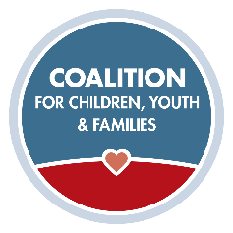**Recruitment Series Self-Paced**

Exercises for Recruitment Video 3

1. Who are the target audiences in your community where you might be able to recruit exceptional foster parents?
2. What message will you use when communicating with this target audience?
3. What messaging elements from this recording will be useful in your recruitment campaign?
4. How are you incorporating your agency’s data on children and foster parents into your messaging?
5. How are you utilizing websites, mass media, and social media in your recruitment campaign?
6. What messaging materials do you plan to use in your campaign? (i.e., brochures, posters, yard signs, banners, videos, PSAs, images)
7. After seeing this video, how will you do booths differently?